**Git -(desktop application run on local machine use Download git Bash for run git )**

**gibash -linux compatible**

**Cmd - window compatible**

**github(Distributed application)**

**Repository (Folder)**

Create repository in git hub using following steps:-

1. Click on new button
2. Add repository name
3. Click on create repository button for creating new repo

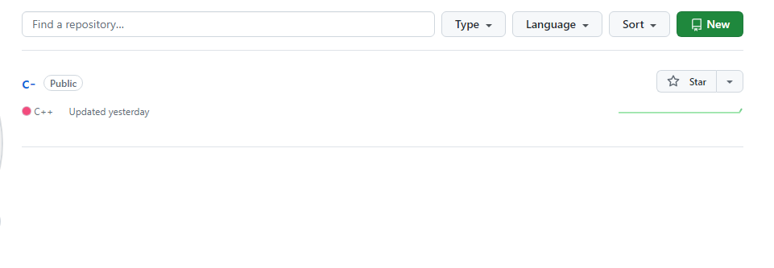

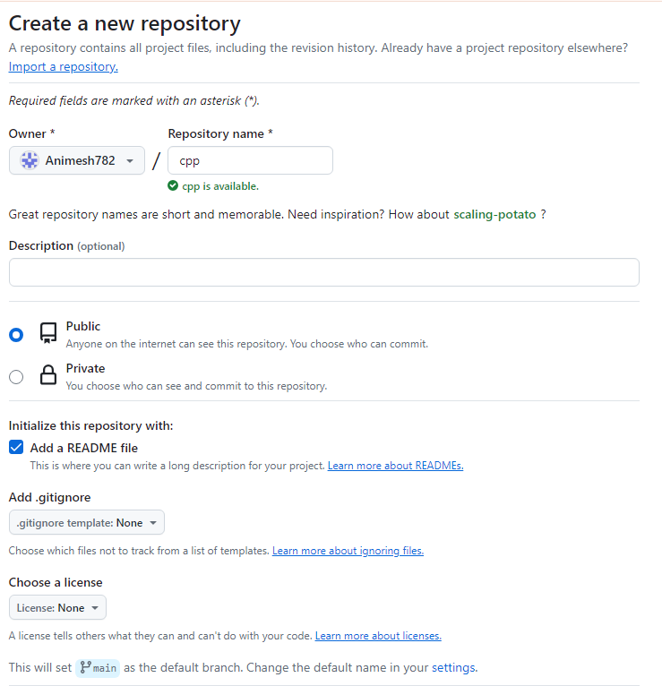



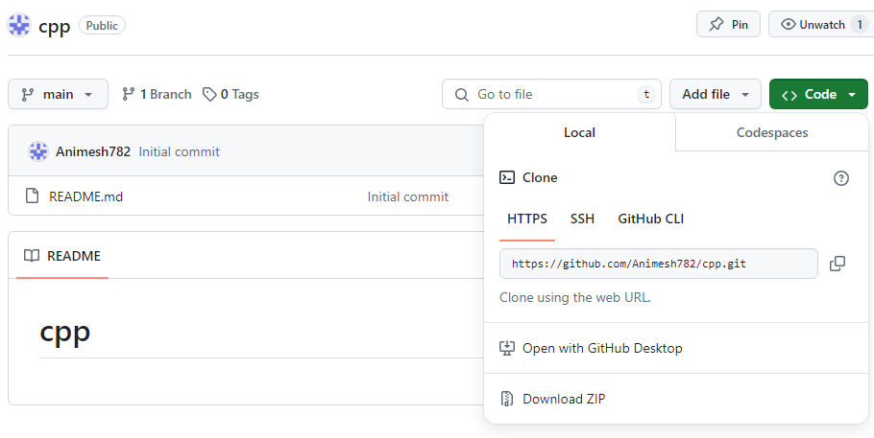

**Git command**

1. Git -v

Used to check version

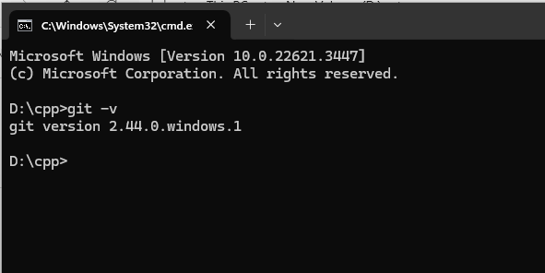

1. Git init

This command is used to create local repository

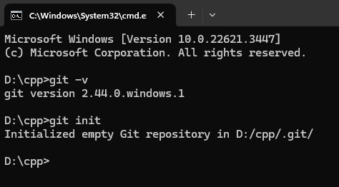

1. Git clone

This command is used to make local copy of a repository from en existing URL.if i wan t a local copy of my repository from github this command allows creating a local copy of that repository on your local directory from the repository url

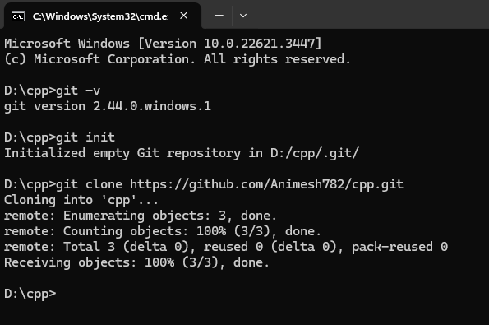

1. Git pull- get folder github

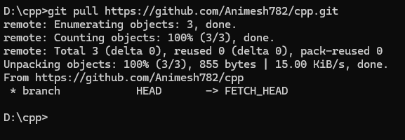

1. Git add <filename>

Git add *

This command is used to add one or more files to staging (Index) area.

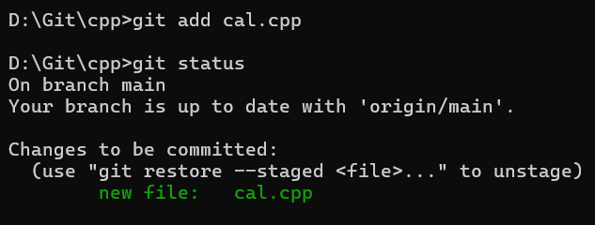

1. Git commit -m “<Message>”

This command changes the head it record or snapshot the file permanently in the

Version history with a message

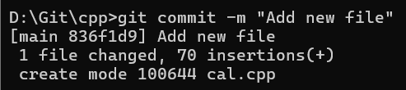

1. Git status

The status command is used to display the state of the working directory and the staging

area.



1. Git push origin <branch name>-(send folder on github)

This command sends the changes made on the master branch to your remote repo

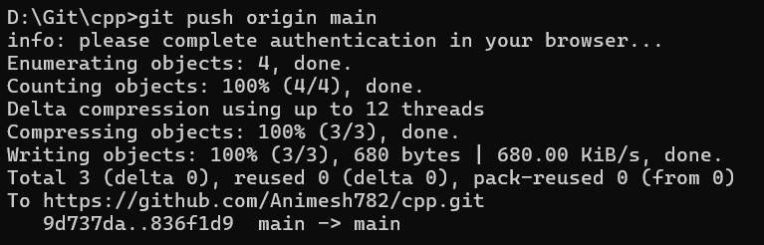

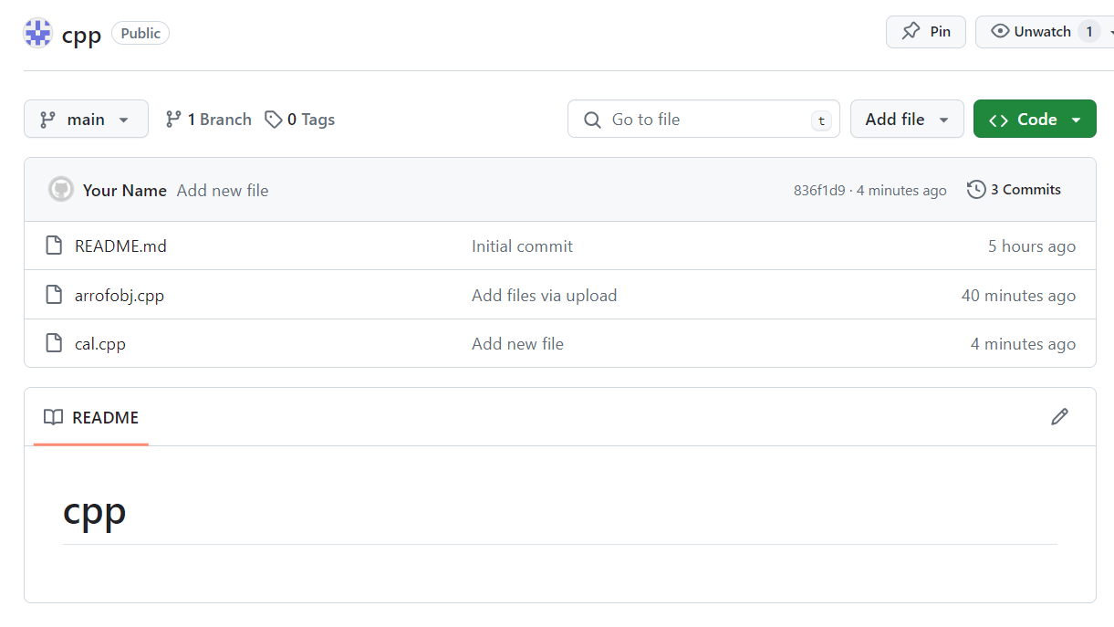

9. Git branch :-

To check current branch

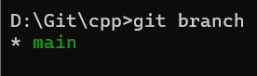

10. Git checkout:-

To create new branch named **cpp1**

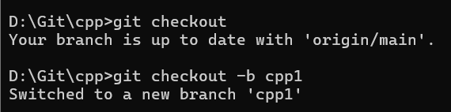

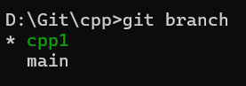

11.Git checkout -b main (change branch)

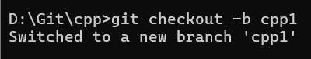

12.Git Checkout main :-

For switching to main branch

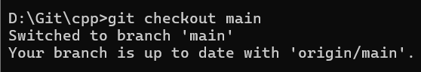

13. Git push origin <branch file name> :-

For push file into branch

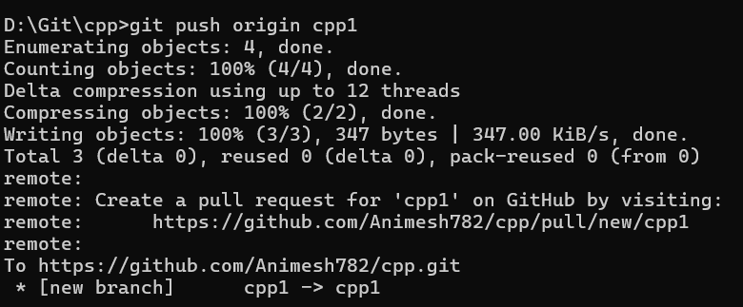

14. Git diff main :-

To compare commits,branches,files and more

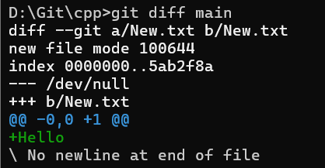

15.Git merge <one branch ><second branch>

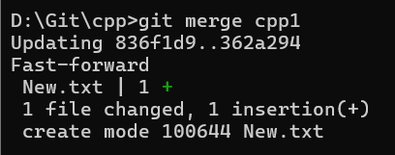

**JIRA :-**

